See also:

参考

• Web Service Integration

Web Service 集成

Advanced Integration Service

高级集成服务

The Advanced Integration Service gives us the ability to define a service that is implemented by an IBM BPM Advanced SCA Module.

先进的集成服务使我们能够定义一个服务,由IBM BPM实现的先进的SCA模块。

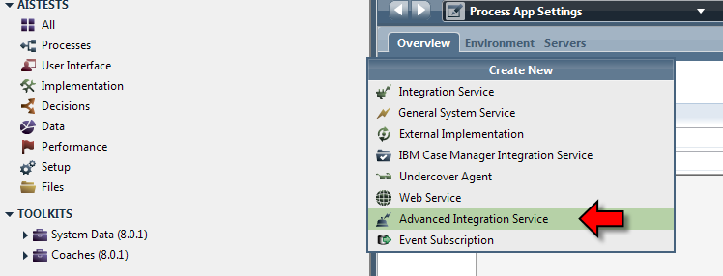

See also:

* Inter-operating between a BPMN process and an SCA module
* DeveloperWorks - Linking business processes and enterprise services together using IBM Business Process Manager Advanced - 2012-09- 26

General System Service

普通系统服务

A general system service is used when the BPD needs to work with the data in the process but does not need to invoke either a Web Service or Java Code. The General System Service is the simplest of the service implementation environments.

一个普通系统服务是在BPD需要处理数据过程中,但不需要调用一个Web服务或Java代码的情况下被使用的。普通系统服务是最简单的服务实现环境。

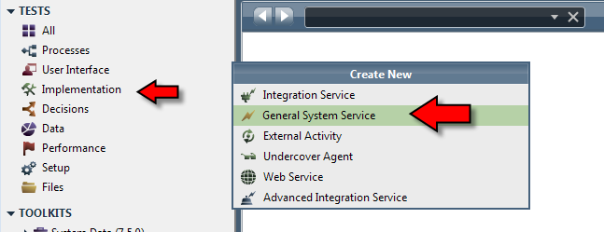

Decision Service

决策服务

During the execution of a process, we may wish to have rules executed. Commonly, rules are decision points in a process where the values of variables in the process are used to determine what to do next. An illustrative example would be to determine the discount to apply for volume orders.

在执行的过程中,我们可能希望有规则执行。通常,规则决策点在一个流程变量的值在这个流程中用来确定下一步做什么。一个说明性的例子是确定申请的折扣卷订单。

Page 257

We may have the following notion:

|  |  |
| --- | --- |
| **Order Value** | **Discount** |
| $0-$999 | 0.00% |
| $1000-$1999 | 5.00% |
| >$2000 | 10.00% |

Looking at this table we see that the discount amount is a function of the order value and hence there is a decision to be made on the discount based on the value of the order. This is the type of function that is ideally suited to Decision Services.

看这个表，我们看到折扣金额是订单值的一个函数值，因此有一个基于订单金额的决策，这是一个适合决策服务的函数类型。

A Decision Service is added to the Library by selecting decisions and adding a Decision Service.

通过选择《决策》和添加一个《决策服务》来将一个决策服务添加到库中

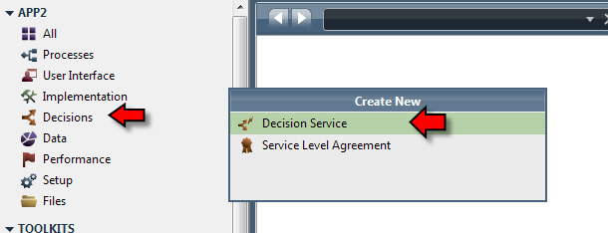

When selected, a new dialog appears into which the decision service name can be entered:

选择时，将出现一个新的对话框，在对话框中输入服务的名字。

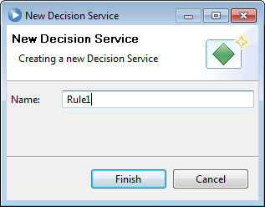

Upon completion of the decision service creation, a panel is shown allowing us to specify the details of the decision:

上面决策服务创建完毕后，一个面板允许我们去指定服务的细节。

Page 258

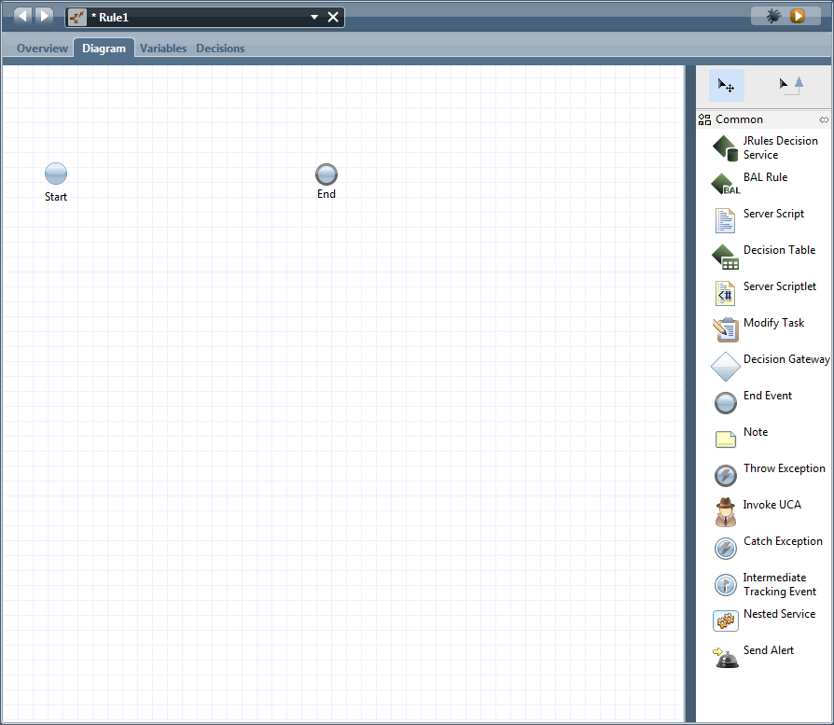

Similar to other service descriptions, we now have the ability to create a service implementation using the building blocks of service creation. For a decision service, we have three items that are specific to this type of service. These are:

类似于其他服务描述，我们现在有能力用多块的服务组合创建一个服务实现，对于一个决策服务来说，我们有三个名目来特有的这种service的类型。

• JRules Decision Service – This decision implementation leverages an external instance of the IBM JRules product which is a full function BRMS.

JRules决策服务－这一决策实现利用了一个有完整BRMS功能的IBM JRules

产品的外部实例

• BAL Rule – This decision implementation type uses the Business Action Language (BAL) as found in the JRules product. No other product is required to use this capability.

BAL 规则 这一决策实现类型使用了JRules 产品中的业务操作语言，没有其他产品需要使用此功能。

• Decision Table – This decision implementation type is the same as found in previous releases of the Lombardi product.

决策表－这一决策实现类型和Lomardi 之前的版本一样。

## Business Action Language (BAL) Rule

业务操作语言(BAL)规则

The Business Action language (BAL) Rule mechanism allows us to define a series of if/then/else conditions based on the current values of the variables in the process. When a BAL rule is added to the service canvas it looks as follows:

业务操作语言(BAL)规则机制允许我们基于流程变量当前值去定义一系列 if/then/else条件。一个BAL规则添加到服务画布中它看起来像下面：

Page 259

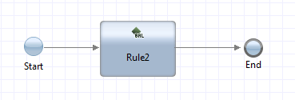

Switching to the Decisions tab allows us the ability to enter the details of the rule using BAL.

切换到决策选项卡允许我们使用BAL输入规则细节。

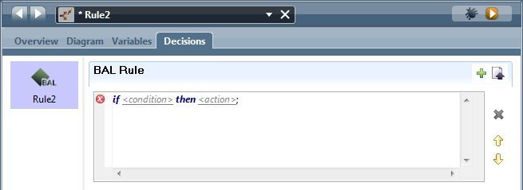

The structure of a business rule is generically:

一个业务规则的结构是一般的

• definitions (optional)

• if

• then

• else (optional)

定义（可选）

如果

那么

否则 （可选）

In the definitions section we can define local variables/values that are used in the remainder of the

rules. For example:

在定义部分我们可以定义在规则剩余部分中使用的本地变量／值，利润

definitions

set low_discount to 5;

定义

set low_discount to 5;

The full language of BAL is described as part of the JRules product and can be found in the InfoCenter article called Business Action Language (BAL).

BAL的语言是做为JRules产品的一部分被描述的。在InfoCenter中可以找到Business Action Language(BAL)的文章。

## Decision Table

IBPM has a concept it calls Decision Tables. To understand what this is about, consider the following concept in a programming language:

决策表

IBPM有个称为决策表的概念，要理解这是什么，在编程语言里考虑以下内容

if (expression A)

{

some code;

} else if (expression B)

{

some code;

} else

{

some code;

}

What this describes is a set of expressions and associated code. When the first expression reached evaluates to true, the associated code is executed. In summary, that is what TeamWorks rules describe. The rules allow us to build expressions based on the values of a set of variables that are in scope. A table is visually constructed. The columns in the table represent the variables and the

这描述了一组表达式和相关的带吗，当第一个表达式d饿求值结果为true,相关的代码执行，总之，这是TeamWorks规则描述的。规则允许我们建立基于一组变量值的范围的表达式，一个表是视觉上的构造，表中的列代表变量和

￼￼Page 260。